Implementing a Threat Hunting-Driven Information Assurance Strategy for Heavy Metal Engineering

Garrett Bates
AMU (Dept. of Cybersecurity)
ISSC660: Information Assurance
Dr. Eralda Nazarko
6/21/2026

Abstract
Industrial & enterprise environments are increasingly subject to cyber threats driven by the convergence and advancements of Information Technology systems. As threats adopt more advanced and persistent techniques, traditional perimeter-based security architectures are proving to be less effective in detecting and mitigating intrusions in a timely manner. This project paper proposes a threat-hunting–driven information-assurance strategy to strengthen the cybersecurity posture of industrial organizations. The approach emphasizes proactive identification of anomalous activity through hypothesis-driven investigation, continuous monitoring, and intelligence-informed analysis. Heavy Metal Engineering (HME) a company specializing in global manufacturing and industrial engineering will be utilized as an example organization to contextualize the application of this strategy within an operational environment.

Contents
Introduction…………………………………………………………………………………….....4
Information Assurance in an Enterprise Perspective…………...…………………………………5
Assets to Protect………………………………………………………………….………..5
Common Threats………………………………………………………………..…………6
IA Framework & Security Strategy for HME…………………………………………..…………7
Tailored Approach………………………………………………………………...………8
Security Measures to Implement at HME…………………………………………………………9
Threat Hunting Program……………………………………………………...………….10
Security Operations Center (SOC) ……………………………………………...……….11
Security Tools.……………………………………………………………………..….....11
Threat Hunting Playbook with XSOAR…………………………………………………………12
Risk Mitigation Strategy: Implementing Security Controls & Compliance……………..………13
Technical Controls……………………………………………………………………….15
Administrative Controls………………………………………………………….………15
Security Culture…………………………….……………………………………………15
Incident Response & Disaster Recovery……………....…………………………………………16
Incident Response Plan (IRP) …………….......…………………………………………17
Disaster Recovery (DR) & Continuous Monitoring…......………………………………18
Conclusion…………………………………………………….....………………………………19
References……………………………………………………......………………………………21

Introduction
Heavy Metal Engineering (HME) is a global manufacturing organization that produces high-end washer and dryer metal shell casings with suppliers, customers, and offices located internationally. Due to HME’s global infrastructure and reliance on interconnected systems, HME faces significant cybersecurity risks, including ransomware, phishing attacks, insider threats, and supply chain compromises. HME must develop a comprehensive Information Assurance (IA) strategy to protect its data and systems and meet the requirements for receiving third-party funding. This plan outlines how HME will protect its information assets through the implementation of Information Assurance principles, an enterprise IA framework, and cybersecurity strategies, which will be tailored to HME. It also includes a threat hunting program that leverages tools such as XSOAR to proactively identify and mitigate cyber threats, strengthen incident response capabilities, and improve overall security controls and regulatory compliance. Integrating these measures will help strengthen HME's security posture and support its future growth and business operations. The results of this IA strategy will provide details that embedding structured threat hunting practices within security operations can significantly improve organizational resilience against evolving cyber threats in industrial settings.

Information Assurance in an Enterprise Perspective
At the basic level, Information Assurance combines practices and tools to protect data. At the enterprise level, Information Assurance focuses on ensuring the CIA triad (confidentiality, integrity, and availability), as well as authentication and non-repudiation of information, through consistent risk management, security controls, and governance across all systems and operations. For many organizations, Information Assurance (IA) is the practice of protecting globally distributed digital and operational systems by ensuring the confidentiality, integrity, availability, and authenticity of critical information while maintaining secure access for business operations. “Information Assurance focuses on safeguarding interconnected systems that manage customer data, intellectual property, employee records, financial information, and manufacturing controls from evolving threats such as hacking, malware, phishing, and ransomware” (Dewey, 2023). Cybersecurity-based IA strategies involve identifying key assets, assessing risks, and implementing layered security controls to prevent unauthorized access, data corruption, and operational disruption. It also ensures that systems remain reliable and that any unauthorized activity is detectable and traceable, supporting secure and continuous global operations.
Assets to Protect
“As outlined in NIST Special Publication 800-12 Rev. 1, Information Assurance (IA) focuses on protecting information and systems by ensuring confidentiality, integrity, availability, authentication, and non-repudiation” (Sykes, 2024). Within HME’s IA strategy, this approach is applied to protecting assets such as customer data (PII), their manufacturing systems, intellectual property, and employee information by combining cybersecurity protections with broader governance, policy, and control measures. Unlike cybersecurity alone, information security and assurance emphasize ensuring data remains accurate and available to support operational needs and decision-making across HME’s environment. “An effective IA strategic plan identifies these critical assets, assesses risks, implements appropriate safeguards, and establishes continuous monitoring to maintain alignment with business objectives and regulatory requirements” (Sykes, 2024). Ensuring employees have training & certifications such as CISSP, CISM, and GSLC further strengthens this strategy by ensuring security personnel have the knowledge needed to effectively manage risks and protect HME’s essential information systems.
Performance plans will be integrated into HME and lists of assets to protect will also be included. HME will use its internal portal website to secure internal documentation and its Google Workspace for other documents & procedures. The categories of these assets include but are not limited to:
- Backup & Disaster Recovery Systems – continuity and recovery of data
- Customer & Financial Data – global client records + accounting & investor information
- Employee Information – HR & payroll records
- Enterprise IT systems – corporate networks and platforms
- Intellectual Property (IP) – designs and engineering specs
- Manufacturing Systems (OT/ICS environments) – production and automation systems
- Physical Security Systems – access control and surveillance data
- Controlled Unclassified Information (CUI) – controlling documents and data
- Third Party Data – partner and collaboration data
Common Threats
Heavy Metal Engineering (HME) faces threats like ransomware, phishing, insider threats, and supply chain attacks that can disrupt operations, steal data, or compromise manufacturing systems. Ransomware can shut down systems, phishing can trick users into giving up access, insider threats can come from trusted employees or vendors, and supply chain attacks can use third parties to reach HME systems. To reduce these risks, HME can use employee and vendor badging systems to control physical access to facilities and sensitive areas. These badges ensure only authorized people can enter, limit vendor access time, and improve tracking of who is in the building. This strengthens physical security and supports HME’s overall information assurance strategy.
Given increasing cybersecurity risks, Heavy Metal Engineering (HME) should adopt a balanced information assurance (IA) strategy that combines both proactive and reactive controls to protect its global manufacturing and information systems. “Proactive controls focus on preventing attacks before they happen through employee training, strong security policies, regular system updates, vendor security requirements, and technical safeguards like multifactor authentication, strong passwords, encryption, and network protections. These measures are especially important for reducing risks such as phishing and supply chain attacks, which often target human behavior and weak access controls” (Patel, 2023). Reactive controls, on the other hand, focus on detecting, responding to, and recovering from incidents after they occur through tools like intrusion detection systems, system logging, antivirus scanning, network segmentation, backup systems, and formal incident response and disaster recovery plans. For HME, this means ensuring that even if ransomware or insider threats impact manufacturing systems or data, operations can be restored quickly and damage is minimized.

IA Framework & Security Strategy for HME
Information Assurance (IA) is critical to HME because it helps protect the confidentiality, integrity, and availability of organizational data and systems. To strengthen its security posture, HME will implement security by design principles, secure system configurations, and a Zero Trust architecture that continuously verifies users and devices before granting access. “Implementing a Zero Trust security model means that no user, device, or system will be automatically trusted, regardless of whether it is inside or outside the network. Every access request must be authenticated, authorized, and encrypted before access to organizational resources is granted” (Chapple, 2024), HME will also conduct vendor security audits to help mitigate the risk of supply chain attacks. By assuming that a breach could occur at any time and enforcing principles such as least privilege and network segmentation, HME can reduce the risk of unauthorized access, limit lateral movement by attackers, and strengthen its overall cybersecurity posture.
Tailored Approach
Ensuring to keep security controls simple & effective throughout an organization will reduce cybersecurity risks while improving compliance and assisting in assurance of the protection of critical information assets from modern threats. HME will use the NIST Cybersecurity Framework (CSF 2.0) and tailor it to fit HME’s needs in conjunction with NIST SP 800-53 which will help with security structuring while providing HME with an industry-recognized way to build, manage, and update its Information Assurance program. Some of the more specific tailoring will be aligning CSF functions to HME’s risks, mapping NIST SP 800-53 controls to current systems, and prioritizing controls based on impact and threat level, reinforcing zero trust. Additionally, the tailoring process will include refining security baselines to better reflect HME’s operational environment, regulatory requirements, and resource constraints (budget, staffing, and technical resources). Continuous monitoring capabilities will be emphasized to provide ongoing visibility into system performance, vulnerabilities, user activities, and emerging threats by conducting threat hunts. By regularly assessing the effectiveness of implemented controls and adapting security measures as the threat landscape evolves, HME can maintain a cybersecurity program that remains practical, resilient, and aligned with organizational objectives.

Security Measures to Implement at HME
Security measures are important for any organization. In HME's case, Multifactor Authentication (MFA) will help bolster security measures by requiring users to authenticate in multiple ways. For example, users can use an access badge and a PIN to verify their identity when logging in on a workstation. Network segmentation is used to separate critical systems, such as laboratory systems and sensitive data repositories, from general user networks to reduce the risk of lateral movement in the event of a breach. At HME, a demilitarized zone (DMZ) will be used to host external services like web portals and remote access tools while keeping internal systems separated from the internet, this will help protect critical systems from direct exposure. Additionally, vulnerability scanning is conducted on a regular basis to identify weaknesses in systems, applications, and network devices, allowing HME to proactively address security gaps before they can be exploited by threat actors. At HME, security measures include both preventive and detection-based controls to strengthen overall cybersecurity postures with the integration of preventative tools like firewalls & secure system configurations to help reduce the risk of unauthorized access, while detection methods such as monitoring tools and alerts identify suspicious activity that might already be inside the network. “Penetration testing is used to identify how attackers could exploit vulnerabilities, providing a snapshot of system weaknesses that can be fixed through remediation. In contrast, threat hunting focuses on actively searching for signs of malicious activity already present in the environment by analyzing real-time behavior and network patterns” (Maloney, 2023). While HME’s IA strategy focuses primarily on threat hunting, HME will combine both threat hunting and pen-testing approaches to identify potential entry points and detect threats that may have bypassed existing defenses.
Keeping it simple is one of the better things an organization can do since clear processes combined with straightforward security measures are easier for employees to follow and maintain consistently. “Know what normal is, and look for abnormal” (Spitzner, L., & Sans Institute, 2020). HME will be implementing this to quickly identify any indicators of compromise and using the ultimate list of SANS cheat sheets, particularly using the ‘Digital Forensics & Incident Response’ and specific ‘General IT Security’ sections, such as the Security Incident Survey Cheat Sheet for Server Admins to improve organizational security awareness, incident response capabilities, and overall threat detection effectiveness.
Threat Hunting Program
HME’s threat hunt program consists of conducting threat hunt meetings on a weekly basis via Teams/Google Meet to find vulnerabilities and conduct patches and remediations as needed. The meetings will go over what was found and how the threat hunts can improve IA. The threat hunts will use OSINT combined with organizational insights at HME to proliferate cybersecurity measures and HME’s strategy to increase resilience to security threats. The Threat Hunt program at HME will consist of conducting threat hunts daily in conjunction with other SOC related duties. HME’s threat hunt program will be used to identify vulnerabilities, detect potential threats, conduct patches and perform remediations to reduce the attack surface at HME, improving the IA strategy and strengthens cybersecurity measures. Findings from each threat hunt will be documented, reviewed, and incorporated into HME’s risk management process to support continuous monitoring and proactive defense against emerging cyber threats. By regularly assessing systems and addressing security gaps before they can be exploited, HME can reduce risk, improve resilience, and better protect sensitive patient and organizational data.
Security Operations Center (SOC)
The Security Operations Center (SOC) provides continuous 24/7 monitoring (automated and active), threat detection, and incident analysis to help safeguard HME’s information systems and critical assets. By leveraging advanced security tools, real-time monitoring capabilities, and skilled cybersecurity analysts, the SOC identifies suspicious activities and investigates security events while responding to incidents in a timely manner, which meet SLA’s within HME. This approach will enable rapid detection & containment of cyber threats, minimize operational disruption and support HME’s overall security posture and IT environment.
Security Tools
The Security Operations Center (SOC) team will leverage Microsoft Sentinel, Splunk, and Cortex XSOAR to continuously monitor, analyze, and respond to cybersecurity incidents across HME’s environment. Microsoft Sentinel & Splunk will collect and correlate security logs from endpoints, servers, networks, cloud services, and applications to detect suspicious activity and generate real-time alerts. SOC analysts will use these platforms to investigate threats, identify attack patterns, and assess the impact of security incidents. Cortex XSOAR will automate incident response workflows, enabling the SOC team to quickly contain threats, block malicious IP addresses, isolate compromised devices, and escalate critical incidents when necessary. Additional security tools such as Endpoint Detection and Response (EDR), Multi-Factor Authentication (MFA), vulnerability scanners, and threat intelligence platforms will further enhance visibility, strengthen security controls, and support rapid decision-making to minimize risk and operational disruption.
Threat Hunting Playbook with XSOAR

XSOAR Playbook Workflow for Heavy Metal Engineering (HME)XSOAR Playbook Workflow for Heavy Metal Engineering (HME):
- Alert Received from SIEM
Security alerts from HME’s IT and OT environments are forwarded to the Cortex XSOAR dashboard, where incidents are automatically created with key details such as incident ID, alert name, severity, source, and affected systems.
- Threat Intelligence Enrichment
XSOAR correlates indicators of compromise (IOCs) such as IP addresses, hashes, domains, and user activity against internal and external threat intelligence feeds to identify known threats and malicious activity.
- Automated Investigation
Automated investigations collect endpoint, network, and log data to determine the scope, severity, and potential impact of the incident on HME operations.
- Endpoint Isolation
If malicious activity is confirmed, affected endpoints are automatically isolated to prevent lateral movement, data loss, or disruption to critical systems.
- Analyst Review
Security analysts review investigation results, validate response actions, assess operational impact, and determine additional remediation or escalation requirements.
- Recovery & Reporting
After remediation, systems are restored, and XSOAR generates incident reports documenting the timeline, response actions, affected assets, and final resolution.
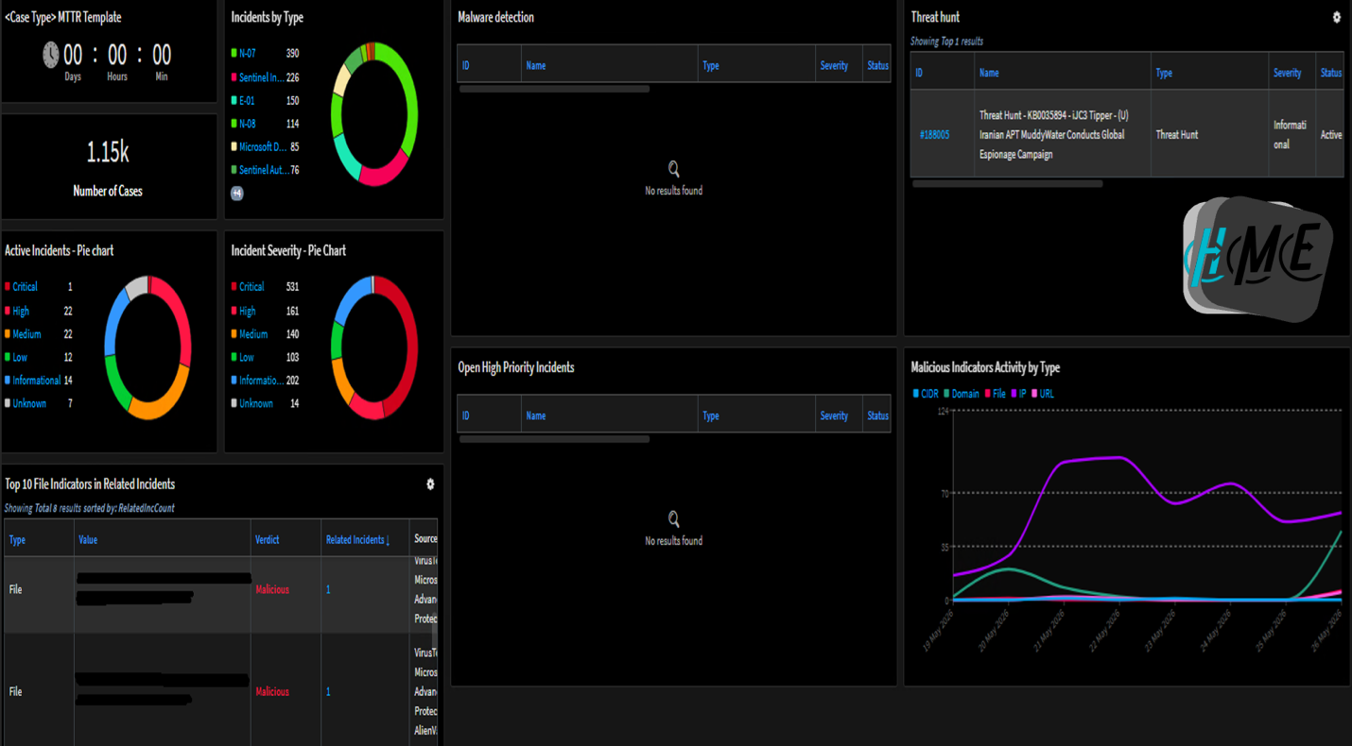
(HME XSOAR Example Dashboard for SOC/Cyber Team, Image Created by Garrett Bates using XSOAR, 2026)

Risk Mitigation Strategy: Implementing Security Controls & Compliance
HME will adopt the NIST Cybersecurity Framework (CSF) to guide its risk mitigation strategy and ensure security controls remain current and effective. The framework will primarily be used to identify critical assets and risks, effectively responding to security incidents in a structured manner while also recover operations quickly after disruptions. This structured approach helps HME improves resilience against evolving threats. Additionally, this will improve compliance measures within HME and support long-term operational stability, thus supporting the IA plan to keep data assets secure and boost the chances of getting approved for third-party funding for an international joint venture.
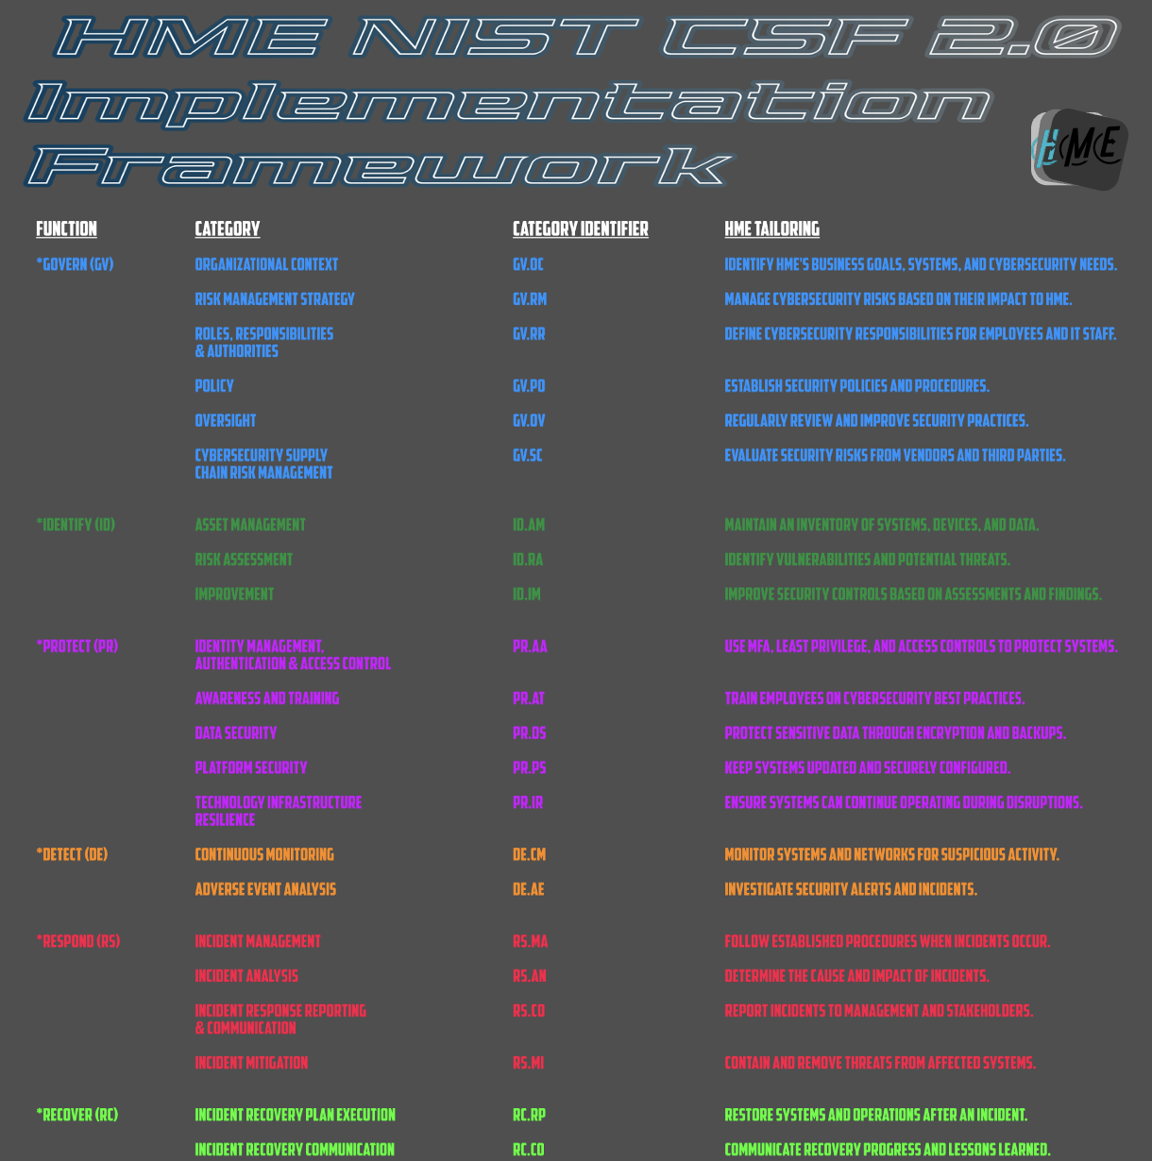
(HME CSF 2.0 Adaptation for IA strategy, Image Created by Garrett Bates, 2026)
Technical Controls
HME will implement technical controls to protect its IT and OT environments, including firewalls, encryption, antivirus/EDR, IDS/IPS, and SIEM tools like Microsoft Sentinel and Splunk. These systems will assist in providing real-time monitoring, threat detection, and log analysis across global operations. Access controls will be implemented as well, since HME will be creating “network rules limiting communication between systems to reduce attack paths” (Swanagan, 2025). Detective controls (SIEM monitoring, log analysis) and preventative controls (patching, hardening, MFA, account disablement) work together to detect threats early and reduce vulnerabilities before exploitation.
Administrative Controls
HME will use administrative controls to manage security policies and user behavior, including access control policies, onboarding/offboarding procedures, acceptable use policies, and security training for employees and vendors. Vendor assessments will be conducted at least once per year for improved security and to reduce the risk of a breach. These ensure proper authorization and minimize risks like phishing and insider threats. Physical controls such as badge access, surveillance cameras, biometric systems, and secured facilities support these policies by restricting unauthorized physical access to critical systems.
At HME, access control procedures define how user access is approved, monitored, and revoked across various IT systems. “Access is granted based on job role and business need, with approvals required from system owners” (Swanagan, 2025). Access is regularly reviewed to ensure permissions remain appropriate, especially for employees, contractors, and third-party vendors, essentially emphasizing the principle of least privilege (POLP).
Security Culture
HME will provide annual cybersecurity training and ongoing security awareness programs that use interactive learning, phishing simulations, and real-world examples to keep employees engaged and informed about cybersecurity risks (not death by PowerPoint). Meetings will be conducted with key stakeholders and partners embracing security culture and discussing security-based topics, even if it’s just for a brief amount of time. Additionally, HME’s cybersecurity team and trusted security vendors will continuously support the security culture by making recommendations as wanted in channels and chats for managers to look through.

Incident Response & Disaster Recovery
For incident response planning and disaster recovery, HME will follow the guidance provided by the Incident Response Recommendations from NIST SP 800-61 to establish a structured process for handling cybersecurity incidents. HME will develop and maintain an incident response plan that outlines procedures for detecting, containing, eradicating, and recovering from security events, and clearly defines employee roles and responsibilities. Regular testing, training, and post-incident reviews will help ensure an organization can respond effectively to cyber threats. In support of disaster recovery, HME will maintain secure backups, recovery procedures, and business continuity plans to restore critical systems and data quickly after an incident, minimizing downtime and ensuring the continued delivery of healthcare services.
One scenario at Heavy Metal Engineering (HME) could be when HME is relying on third-party suppliers and the external vendor credentials get compromised, leading to unauthorized access attempts into HME systems. The Incident Response Team is alerted through SIEM/XSOAR when unusual vendor activity is detected, such as abnormal logins or access patterns. “One of the goals for an incident response team should be to identify the compromised accounts, revoke access, and contain any potential lateral movement across IT and OT systems” (Gary, 2025). Evidence includes authentication logs, VPN activity, and security alerts tied to the vendor account. The incident is resolved once access is removed, activity is contained, and vendor security controls are reviewed and strengthened.
Incident Response Plan (IRP)
HME will plan to use the detect, contain, eradicate, and recover method from NIST as part of its incident response strategy to manage cybersecurity events in a structured and effective way. First, HME will detect threats through continuous monitoring, log analysis, and alerting tools to quickly identify suspicious or malicious activity. Once an incident is confirmed, it will be contained by isolating affected systems to prevent further spread within the network. “The eradication phase will focus on removing the root cause of the incident, such as malware, unauthorized access, disabling compromised accounts, applying security patches and conducting validation scans to ensure all threats have been fully eliminated” (Goldstein, 2025).
HME will recover by restoring affected systems and data from secure backups and validating that normal operations can resume safely. HME will establish incident response procedures, assign roles and responsibilities, conduct employee training, and utilize security tools such as SIEM, EDR, and continuous monitoring solutions to detect and analyze potential threats, when a security incident occurs that is affecting one or more critical systems and networks HME will follow a structured process and assemble a tiger team which will consist of subject matter experts in conjunction with the SOC’s security analysts to contain affected systems, remove malicious activity. This will aid in restoring services quickly from secure backups while being able to verify system integrity before returning to normal operations. Following each incident, HME will conduct a lessons-learned review to identify root causes, improve response procedures and update employee training. The goal of conducting this documentation is to provide a continuous improvement process to enhance HME's overall information assurance strategy.
Disaster Recovery (DR) & Continuous Monitoring
HME will use automated and encrypted cloud backups with AWS to protect data and ensure it can be quickly restored after a disruption. Recovery Time Objectives (RTOs) will be established to define how quickly critical systems must be restored, with priority given to essential services. The plan will identify essential systems and personnel, establish communication procedures, and provide backup and recovery processes for critical data and services. HME will define Recovery Time Objectives (RTOs) for essential systems and conduct regular testing to ensure it can quickly recover and resume normal operations. A DR checklist will be updated semiannually or as needed to tailor certain systems and services to the checklist and provide clarity across the board. The DR checklist will cover the following aspects at HME.
HME – Disaster Recovery: Threat to Recovery (HME T2R) Checklist:
- Detect & identify suspicious activity through continuous monitoring and threat hunting.
- Analyze indicators of compromise (IOCs) and determine the scope of the incident.
- Notify management, escalate to the incident response team, and notify key stakeholders.
- Contain affected systems to prevent further damage or spread.
- Preserve logs and evidence for forensic analysis.
- Eradicate identified threats and remove malicious activity.
- Restore affected systems & data from secure cloud backups.
- Verify system integrity and confirm threats have been eliminated.
- Resume normal business operations according to recovery priorities and Recovery Time Objectives (RTOs).
- Conduct a post-incident review, update threat intelligence, and improve security controls to prevent future incidents.
Following a cybersecurity incident, HME will focus on eradicating threats by isolating affected systems. “Organizations should remove malicious files, correct insecure configurations, and apply security patches for vulnerabilities identified during threat-hunting activities” (Thompson, 2018). If system integrity cannot be verified, affected devices will be restored from secure cloud backups or rebuilt from approved baseline configurations. Before returning systems to production, HME will validate that critical services are functioning properly and that no indicators of compromise remain. As systems are restored, HME will maintain continuous monitoring through log analysis, vulnerability scanning, endpoint monitoring, and proactive threat hunting to detect any signs of recurring malicious activity. Following recovery, HME will conduct a post-incident review to evaluate response effectiveness, identify lessons learned, and improve security controls, playbooks, and monitoring procedures. Key metrics such as time to detect, contain, and recover from incidents will be tracked to strengthen HME's overall Information Assurance program.

Conclusion
In conclusion, proactive cybersecurity is a critical component of Information Assurance. HME adapting a threat hunt-driven IA strategy not only helps the company stay on top of evolving threats, but it also gives stakeholders peace of mind and assurance that they can trust HME when threats attempt to impact operations, data, or customers. Threat hunting enables security teams to actively search for hidden threats that may bypass traditional security controls, while automation helps accelerate incident response and reduces the burden on security personnel. These measures not only improve day-to-day security operations but also provide long-term protection for HME’s global business environment, ensuring resilience, business continuity, and the ability to adapt to an evolving cyber threat landscape.

References
Chapple, M., Stewart, J. M., & Gibson, D. (2024). Ch. 8 ISC2 CISSP Certified Information Systems Security Professional Official Study Guide (10th ed.). John Wiley & Sons Inc. https://apus.primo.exlibrisgroup.com/view/action/uresolver.do?operation=resolveService&package_service_id=150063887320005031&institutionId=5031&customerId=5030&VE=true
Dewey, J. (2023). Information assurance (IA) | library and information science | research starters | ebsco research. EBSCO. https://www.ebsco.com/research-starters/library-and-information-science/information-assurance-ia
Gary, H. J. (2025). Cybersecurity Incident Response Drill Scenarios eBook. Amazon. https://www.amazon.com/Cybersecurity-Incident-Response-Drill-Scenarios-ebook/dp/B0FZXNNFMG
Goldstein, J. (2025, November 10). Incident response steps & phases: NIST Framework explained. SentinelOne. https://www.sentinelone.com/cybersecurity-101/services/incident-response-steps-phases/
Patel, A. U., Williams, C. L., Hart, S. N., Garcia, C. A., Durant, T. J. S., Cornish, T. C., & McClintock, D. S. (2023). Cybersecurity and Information Assurance for the Clinical Laboratory. The Journal of Applied Laboratory Medicine, 8(1), 145–161. https://doi.org/10.1093/jalm/jfac119
Maloney, S. (2023). Pen testing vs. threat hunting: Understanding the differences. Cybersecurity Software. https://www.cybereason.com/blog/blog-pen-testing-vs-threat-hunting-understanding-the-differences
National Institute of Standards and Technology. (2024). Cybersecurity framework (CSF) 2.0. U.S. Department of Commerce. NIST Cybersecurity Framework 2.0
National Institute of Standards and Technology. (2020). Security and privacy controls for information systems and organizations (NIST Special Publication 800-53 Rev. 5). U.S. Department of Commerce. NIST SP 800-53 Rev. 5
National Institute of Standards and Technology. (2025, November 20). Incident response. Computer Security Resource Center. https://csrc.nist.gov/projects/incident-response
Spitzner, L., & Sans Institute (2020). Leveraging Organizational Change to Build a Strong Security Culture. Timestamp 35:48, YouTube. https://www.youtube.com/watch?v=_A2f04nIJTc
Swanagan, M. (2025, October 6). The 3 types of security controls (expert explains). PurpleSec. https://purplesec.us/learn/security-controls/
Sykes, N. (2024). Understanding and implementing information assurance in Facilities Portfolio Management and Enterprise Asset Management. R&K Solutions. https://www.rksolutions.com/resources/understanding-and-implementing-information-assurance-in-facilities-portfolio-management-and-enterprise-asset-management
Thompson, E. C. (2018). Cybersecurity Incident Response: How to Contain, Eradicate, and Recover from Incidents (1st ed.). Ch. 9, Apress L. P. https://doi.org/10.1007/978-1-4842-3870-7

